

**WhatsApp Pay**

**SIMPLILEARN PC BA - CBAP CERTIFICATION PROJECT – 3**

Submitted By:

**Rohan Maity**

Table of Contents

Introduction 2

Business Analysis Core Concept Model (BACCM) 3

Project Tasks 5

1. Stakeholder Identification 5

1.1 Internal and External Stakeholder Classification 5

1.2 Stakeholder Activity Analysis 5

1.3 Stakeholder Onion 7

2. Identification of Risks in New Feature 8

3. SWOT Analysis of WhatsApp Pay 9

4. Transition State of WhatsApp Pay 10

5. As-Is and Future State Map 11

5.1 As-Is State 11

5.2 Future State 12

6. Context Diagram Scope of the System 13

7. Main Features to be developed 14

8. In-Scope and Out-of-Scope Items for the Software 15

9. Requirements of the Business 16

9.1 Functional Requirements 16

9.2 Non-Functional Requirements 16

10. Mock Screens for WhatsApp Pay 17

# Introduction

WhatsApp is a messaging and Voice over IP (VoIP) service owned by Meta Platforms, Inc., formerly known as Facebook. It allows users to send text and voice messages, makes voice and video calls, and share images, documents, and other media. WhatsApp runs on mobile devices but is also accessible from desktop computers. WhatsApp has over 2 billion users worldwide as of today. It has become the primary means of electronic communication in multiple countries across multiple continents, including Latin America, the Indian subcontinent, and large parts of Europe and Africa. Today across the globe people are moving to digital payment services such as Google Pay, PayPal, and others. Mobile wallets are in massive demand. The transaction value of the global mobile payments market was USD 3714.5 billion in 2019 and is expected to reach USD 12,407.5 billion by 2025, registering a CAGR of 23.8%. WhatsApp, one of the leading mobile messaging apps, wants to get a slice of this growing digital payment market.

WhatsApp has decided to take the plunge into this digital payment market. They have launched a new feature namely, WhatsApp Payments to be known as WhatsApp Pay in Brazil in June 2020. WhatsApp promises to disrupt the global digital payments ecosystem with WhatsApp Pay. WhatsApp will integrate the customer’s debit card or credit card into their app so that a person can transfer the money to their peers while chatting with them. This feature would be provided to users as an update in the existing WhatsApp messaging app without needing to download a separate app. The user can use the WhatsApp pay feature by updating the WhatsApp messaging app. They are banking on the fact that the popularity of WhatsApp and the sheer number of WhatsApp users will be an added advantage over other payment apps. Now, they have launched the feature in Brazil, and it will be followed by a launch in India and then the rest of the world.



**Figure 1: WhatsApp Logo**

# Business Analysis Core Concept Model (BACCM)

The Business Analysis Core Concept Model or BACCM is a business analysis conceptual framework used to evaluate six core concepts of any given business analysis project or task.

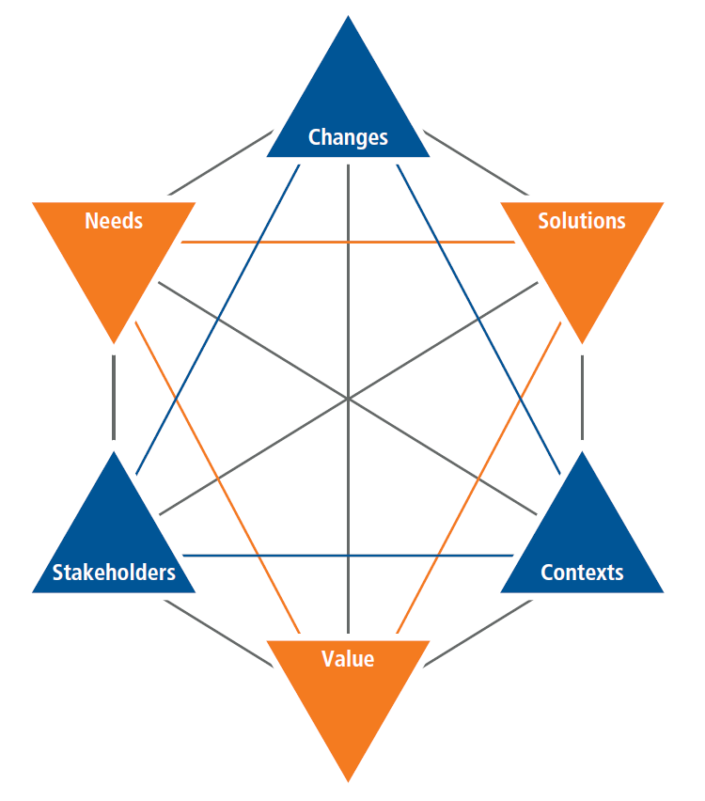

**Figure 2: BACCM Model**

In the context of the opportunity presented to WhatsApp for the creation of WhatsApp Pay, the application of the BACCM model will yield:

|  |  |
| --- | --- |
| **BACCM** | |
| **Need** | * Today across the globe people are moving to digital payment services such as Google Pay, PayPal, and others which has created an opportunity for mobile wallets that are in massive demand. * The transaction value of the global mobile payments market was USD 3714.5 billion in 2019 and is expected to reach USD 12,407.5 billion by 2025, registering a CAGR of 23.8%. * WhatsApp, being one of the leading mobile messaging apps, wants to get a slice of this growing digital payment market. |
| **Change** | * WhatsApp needs to develop a mobile wallet payment system to allow users to transfer and receive money in a user-friendly, hassle-free, and efficient manner. * WhatsApp users should be able to make payments at the same time when using regular WhatsApp services without needing to download any additional software but by just updating their existing App. |
| **Solution** | WhatsApp needs to create a safe and secure, good user-friendly, and scalable mobile wallet payment solution without affecting or creating differences to the current functionalities in the system. |
| **Context** | * Users of WhatsApp * Banks * Debit Card Provider * Credit Card Provider * Management of WhatsApp * Developers * IT Department * Software update for availing the new features |
| **Stakeholder** | * **Internal Stakeholders:** Project Manager, Domain SME, Implementation SME, Tester, Operational Support. * **External Stakeholders:** WhatsApp Users, Facebook, WhatsApp Management, Debit Card Providers, Credit Card Providers, Banks, Reserve Bank of India, and Government Authorities. * **Business Analyst** |
| **Value** | * Customers getting fast and efficient as well as secured, safe, scalable, and user-friendly smart payment facilities in the existing WhatsApp messenger. * WhatsApp can gain a competitive advantage in the global digital payment market due to its user base of over 2 billion users. * WhatsApp will be able to enhance its customer base by adding new features to its application. |

**Table 1: BACCM Core Concepts for WhatsApp Pay**

# Project Tasks

## 1. Stakeholder Identification

### 1.1 Internal and External Stakeholder Classification

The internal and external stakeholders for WhatsApp Pay are:

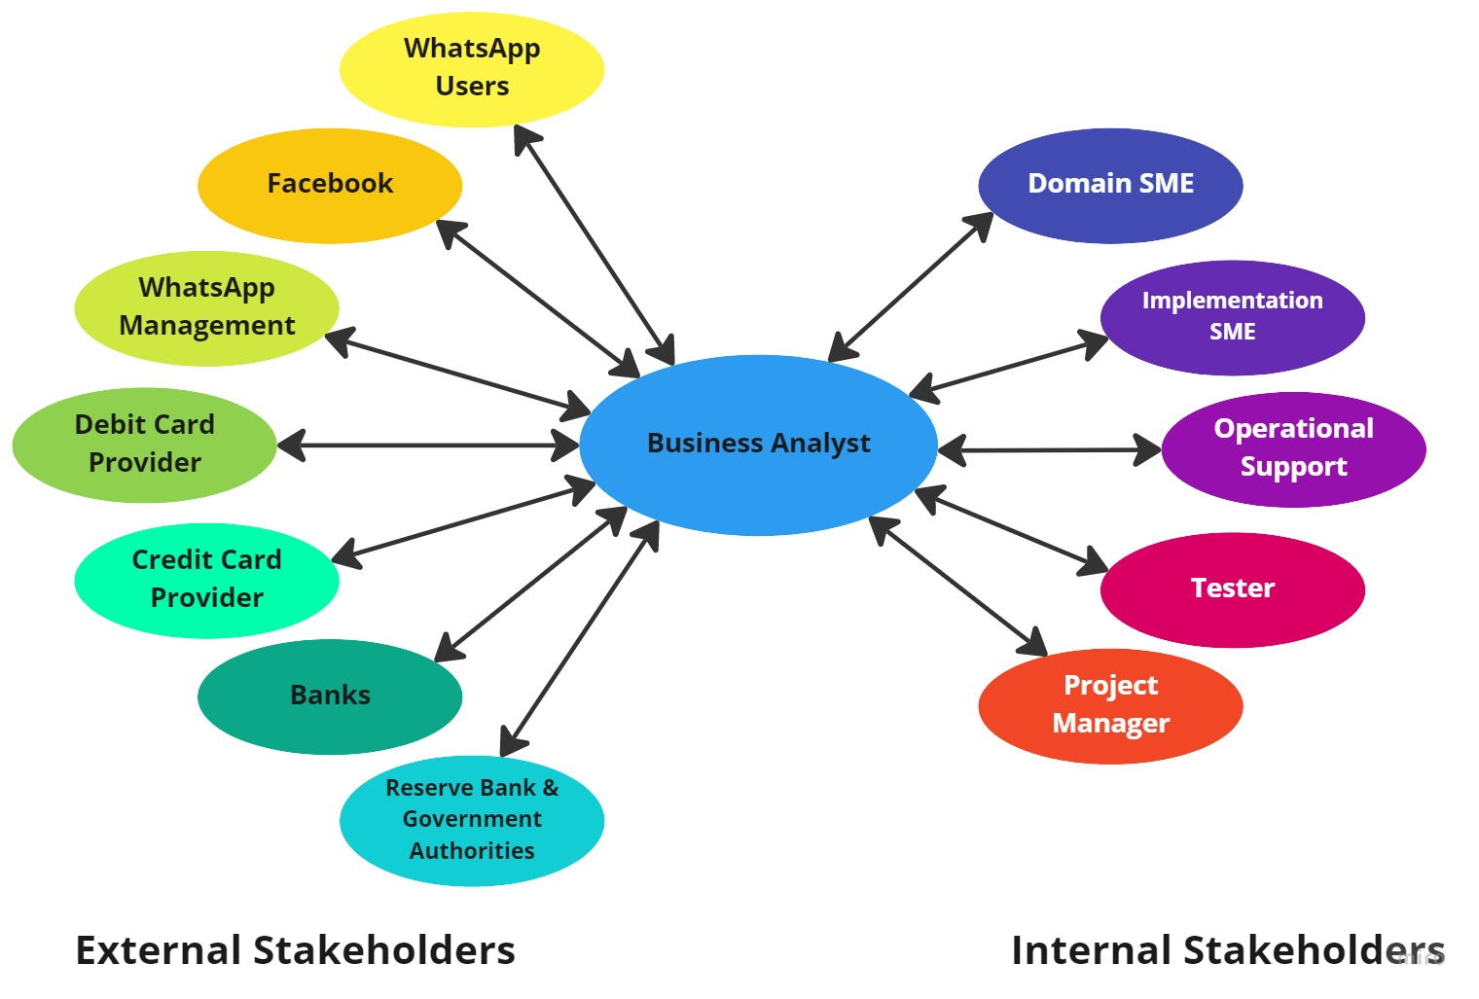

**Figure 3: Stakeholder Classifications**

### 1.2 Stakeholder Activity Analysis

|  |  |
| --- | --- |
| **Actor** | **What they can do on the Software Created** |
| **WhatsApp Users** | * Add debit card and credit card information into the app. * Add bank details for UPI generation into the app. * Transfer money to people on the contact list. * Make fast payments with a single click. * Generate security pins or OTPs. * Send money requests to people on the contact list. * Accept money request/Consent to pay. * Scan QR codes for transactions. * Send text and voice messages, makes voice and video calls, and share images, documents, and other media normally like before while simultaneously making transactions. |
| **Facebook** | * Authorize and approve the need, scope, and budget for the project initiative. |
| **WhatsApp Management** | * The management will use the services and manage aspects of the services to ensure that it meets contractual or moral rights. |
| **Debit Card Provider** | * Authenticate payment through pin. * Verify debit card limit. * Accept the amount from the issuer's bank. * Settle the amount with the acquirer bank. * Execute fund transfer. |
| **Credit Card Provider** | * Authenticate payment through pin. * Verify credit card limit. * Accept the amount from the issuer's bank. * Settle the amount with the acquirer bank. * Execute fund transfer. |
| **Banks** | * Authenticate the request for fund transactions using UPI through WhatsApp Pay. * Reject transaction process in case of invalid details or insufficient account balance. * The issuer bank debits the amount from the user’s account. |
| **Reserve Bank & Government Authorities** | * Regulation of the UPI settlements where the WhatsApp Pay feature needs to be compliant. |
| **Business Analyst** | * Engage with the internal and external stakeholders. * Understand the specific project requirements. * Create BA deliverables and essential documents. * Review solution design and get signoff from stakeholders. |
| **Domain SME** | * Provide inputs on the functional developments of the system. |
| **Implementation SME** | * Take inputs from the internal stakeholders and business analyst. * Develop the WhatsApp Pay feature in the WhatsApp application. |
| **Operational Support** | * Provide customer care support for the employees. * Handle user interface (UI) and provide support for backend development requests. |
| **Tester** | * Perform quality analysis on the system for identifying any bugs or issues. * Verify the functionality of the system before its release for usage. |
| **Project Manager** | * Take actions to help guide the project to completion efficiently and effectively. * Conduct SCRUM calls. * Guide the internal stakeholders for the development and successful release of the system. |

**Table 2: Stakeholders and their Activities in the System**

### 1.3 Stakeholder Onion

The Stakeholder Onion is a diagram that helps to highlight the relationship of the stakeholders with the project goals. In the context of the project of WhatsApp Pay, the Stakeholder Onion will be:

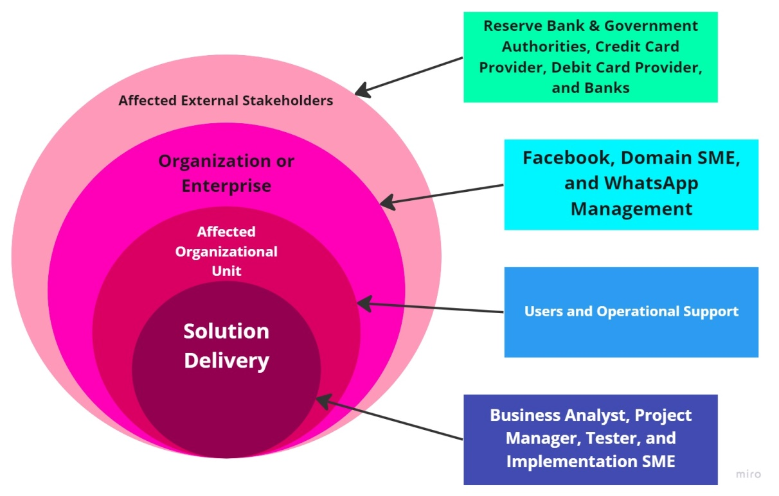

**Figure 4: Stakeholder Onion**

## 2. Identification of Risks in New Feature

Mind Mapping is a tool that is used as part of strategy analysis to identify and categorize potential risks and understand their relationships. In the case of WhatsApp Pay, the risks that can be identified using mind mapping are:

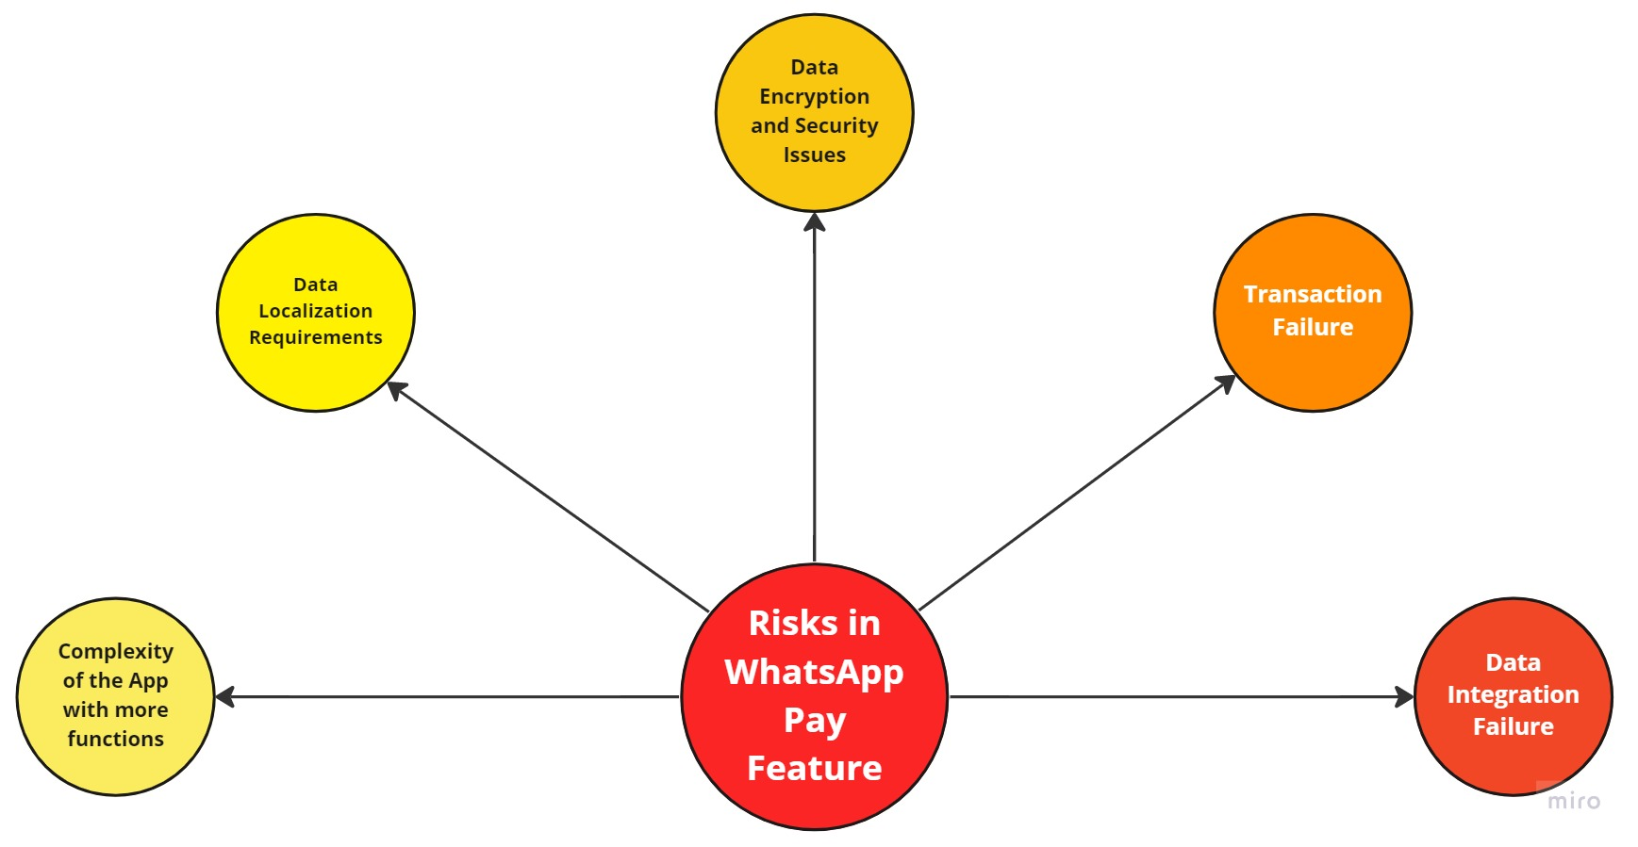

**Figure 5: Mind Mapping for Identification of Risks**

## 3. SWOT Analysis of WhatsApp Pay

SWOT analysis is a technique to identify the strengths, weaknesses, opportunities, and threats of an organization or a system. In the case of WhatsApp Pay, the SWOT analysis will be:

|  |  |
| --- | --- |
| Strengths | Weaknesses |
| * Availability of a large user/customer base of over 2 billion users. * High global popularity and one of the primary means of digital communication across the globe. * Easy and user-friendly interface with support for multiple languages. * Usage of high-end technology that makes the transaction easier, simpler, and more convenient than the regular monetary transaction process. * Single application with integrated features and no additional application need to be downloaded. | * Transactions cannot be made offline and the system is entirely dependent on the internet for the process. * Due to being in a new domain, the system will require approvals from different government authorities which is a time-consuming process. * Strong economic regulations and policies would affect the UPI payment system of WhatsApp Pay. |
| Opportunities | **Threats** |
| * Rapid and continuous development of technology can allow the system to add more features and functions in the future. * The ease and convenience of the payment system can attract more customers/users. * A large customer/user base will allow the company to generate more revenue and profits. * The system will help build and enhance the brand image. | * Data security threats of information hacking, fraudulent transactions, and many such cyber security threats. * Data compliance issues with the regulatory governing bodies. * Competition from other similar UPI Mobile Wallet companies such as Google Pay, PayPal, PayTM, PhonePe, Cashapp, and so on. |

**Table 3: SWOT Analysis of WhatsApp Pay**

## 4. Transition State of WhatsApp Pay

**Current State:**

1. WhatsApp currently has 2 billion users worldwide
2. WhatsApp is the primary mode of digital communication in multiple continents such as Latin America, the Indian subcontinent, Europe, and Africa.
3. WhatsApp provides sharing of texts, media files, and voice and video calling services to users.
4. Mobile wallet digital payment services are a major demand in the modern world allowing people to move to such services.
5. WhatsApp launched a feature in their existing app and this feature is called WhatsApp Pay which is in Brazil alone.

**Future State:**

1. WhatsApp will launch its WhatsApp Pay feature in India.
2. If WhatsApp Pay is successful in India then this feature will be launched in the rest of the world.
3. Gain 1 million users using the WhatsApp Pay feature within the first 3 months of launch.
4. Have 30% of the user base using the WhatsApp Pay feature after 1 year of launch.

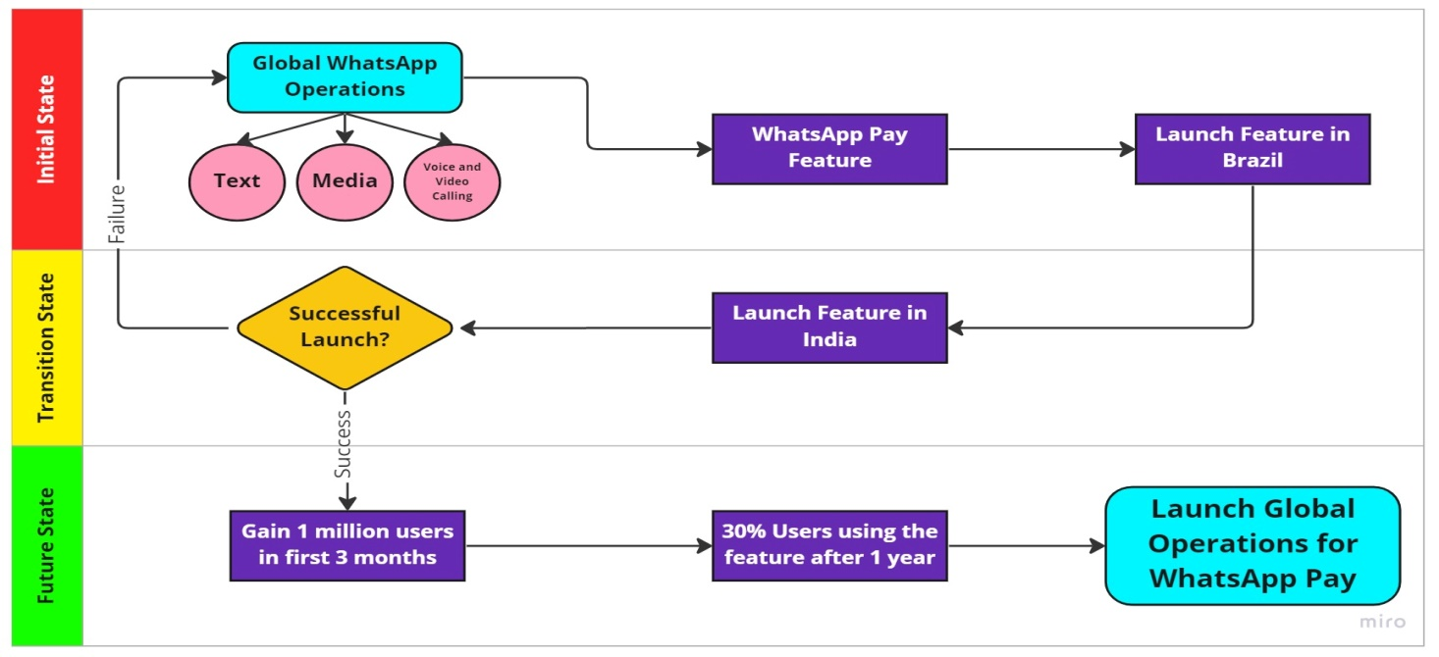

**Figure 5: Transition State of WhatsApp Pay**

## 5. As-Is and Future State Map

### 5.1 As-Is State

The current existing process of WhatsApp can be described using this process flow diagram:

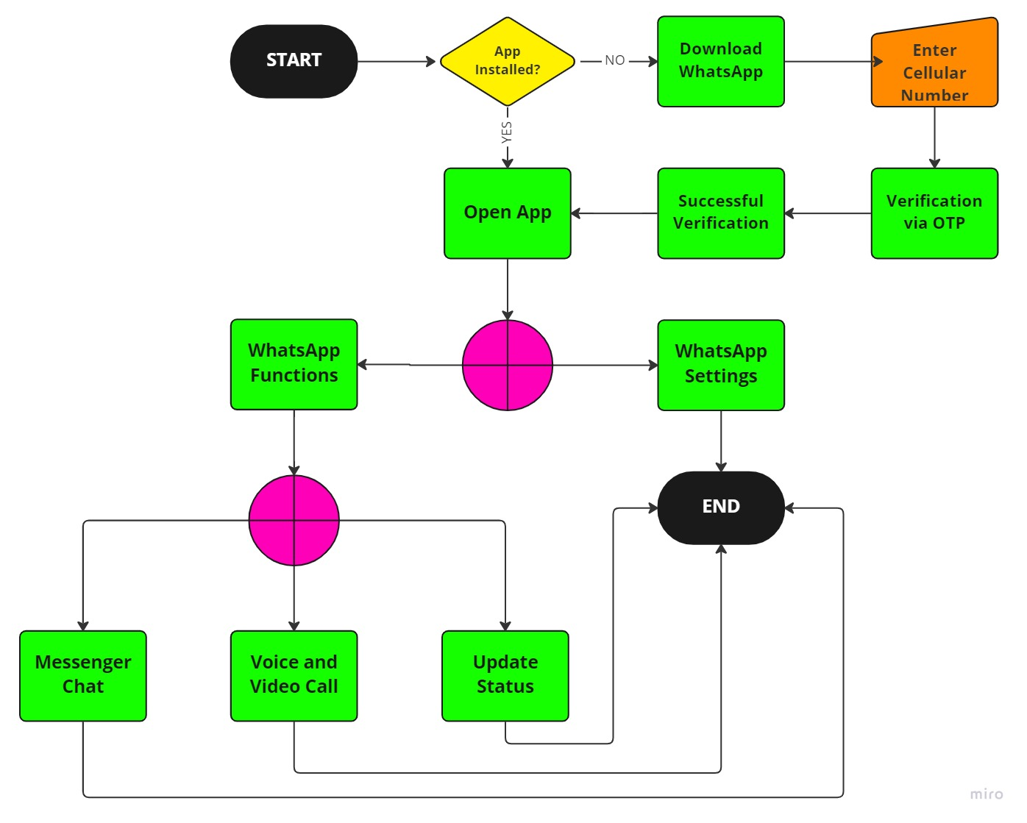

**Figure 6: As-Is State Flow Chart**

### 5.2 Future State

The future process of WhatsApp can be described using this process flow diagram:

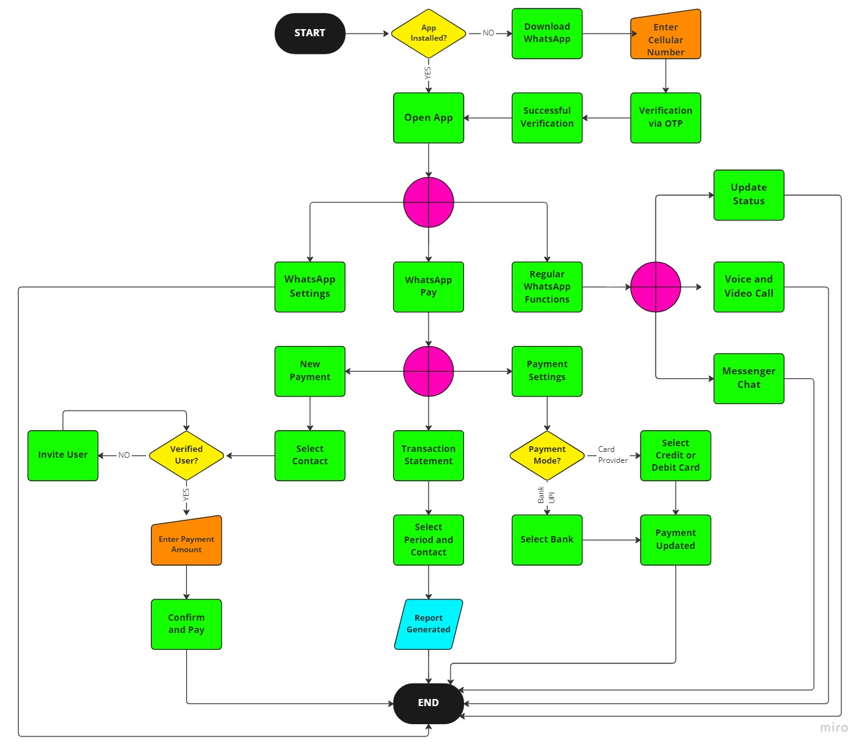

**Figure 7: Future State Flow Chart**

## 6. Context Diagram Scope of the System

The scope of the WhatsApp Pay system can be illustrated using the context diagram:

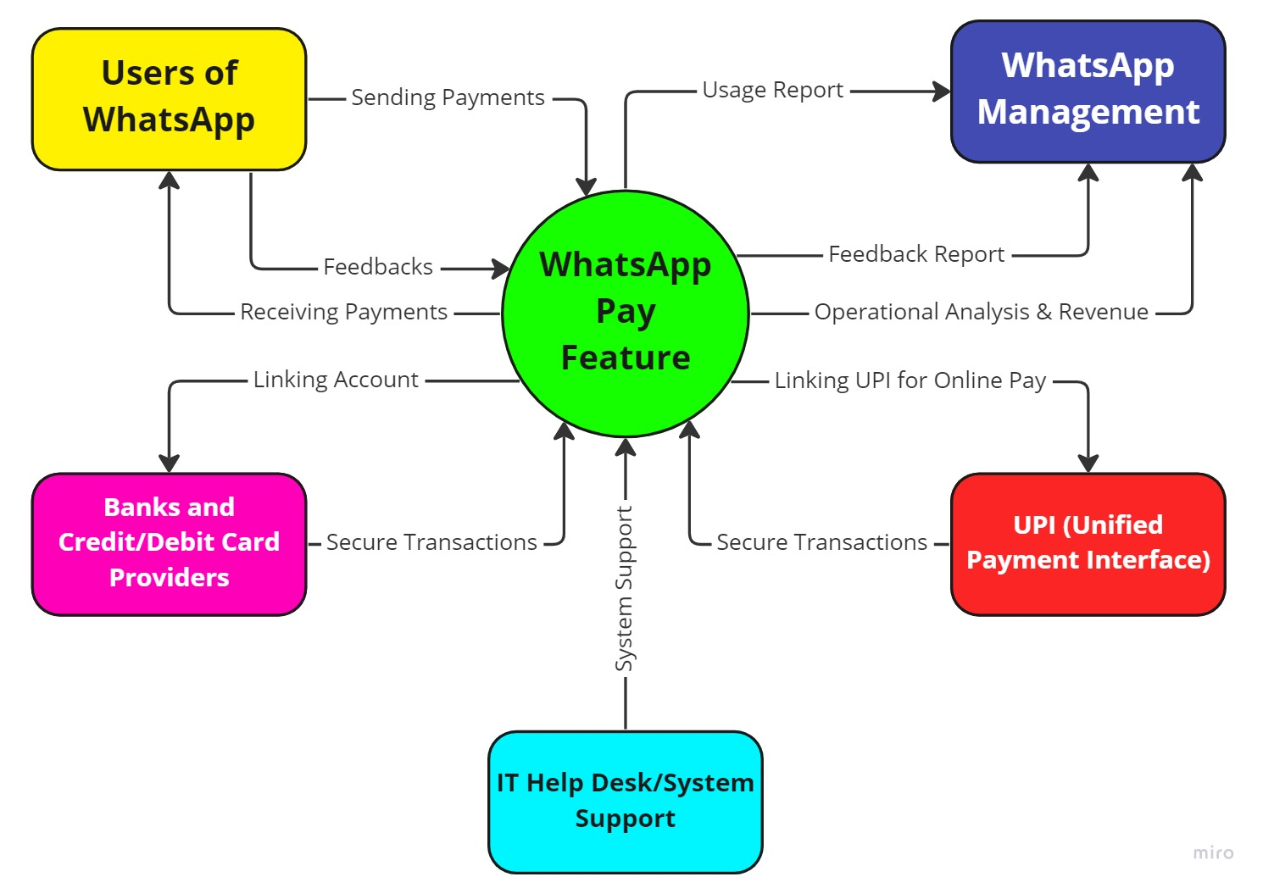

**Figure 8: Context Diagram of WhatsApp Pay**

## 7. Main Features to be developed

The main features that need to be developed for WhatsApp Pay are:

1. One-Click payment system for easy and convenient transaction system.
2. Safe and secured as well as data encrypted mode of payment.
3. Fast and accurate scanning of QR codes and confirmation to send payment.
4. Adding Banks, credit or debit card providers' details as sources of payment.
5. Modification, updating, and deletion of bank details in the app for users.
6. User-Friendly graphics user interface (GUI) for ease of navigation.
7. Constant availability of data for the regulators and WhatsApp Management.
8. Requesting money from contacts.
9. 24/7 service availability and customer support system.
10. Security confirmation and alerting system whenever a transaction occurs.

## 8. In-Scope and Out-of-Scope Items for the Software

The in-scope items and the out-of-scope items for WhatsApp Pay are:

|  |  |
| --- | --- |
| In-Scope | Out-of-Scope |
| 1. Adding, updating, and deleting bank account details. | 1. **Details and balance of the linked bank accounts.** |
| 1. Multiple bank accounts can be added. | 1. **Users who do not have bank accounts or card providers linked in their WhatsApp.** |
| 1. Credit/Debit card providers can be added. | 1. **No e-commerce system for WhatsApp Pay.** |
| 1. Generation of a security pin for payment. | 1. **No actual wallet but banks will be doing the transaction.** |
| 1. Sending and receiving payments. |  |
| 1. Scanning QR Codes. |  |
| 1. Generation of QR Code for the user. |  |
| 1. Requesting money from contacts. |  |
| 1. Payment notifications. |  |
| 1. Generation of transaction statements. |  |
| 1. Generation of reports for WhatsApp Management. |  |
| 1. Availability of multiple languages. |  |

**Table 4: In-Scope and Out-of-Scope Items**

## 9. Requirements of the Business

### 9.1 Functional Requirements

The functional requirements for WhatsApp Pay are:

1. Ability to add/update/change/delete bank accounts into the WhatsApp account of the user.
2. Ability to add/update/change/delete credit/debit card providers into the WhatsApp account of the user.
3. Ability to transfer money to contacts of the WhatsApp user.
4. Ability to transfer money via QR code scanning.
5. Ability to request money from contacts of the WhatsApp user.
6. Ability to generate personal QR code for the WhatsApp user.
7. Ability to accept or reject transaction requests.
8. Viewing transaction log history and transaction statements.

### 9.2 Non-Functional Requirements

The non-functional requirements for WhatsApp Pay are:

1. **Availability:** Available to be used 24/7 and by updating the existing WhatsApp application.
2. **Scalability:** Can easily be used by over 400 million users and followed by over 2 billion users globally.
3. **Security:** Can maintain the security and safety of the transactions and prevent cyber security threats of data theft and hacking.
4. **Usability:** Easy and convenient to use with a user-friendly GUI and having one-click payment system.
5. **Compliance:** Comply with the regulatory and data security policies of the region.

## 10. Mock Screens for WhatsApp Pay

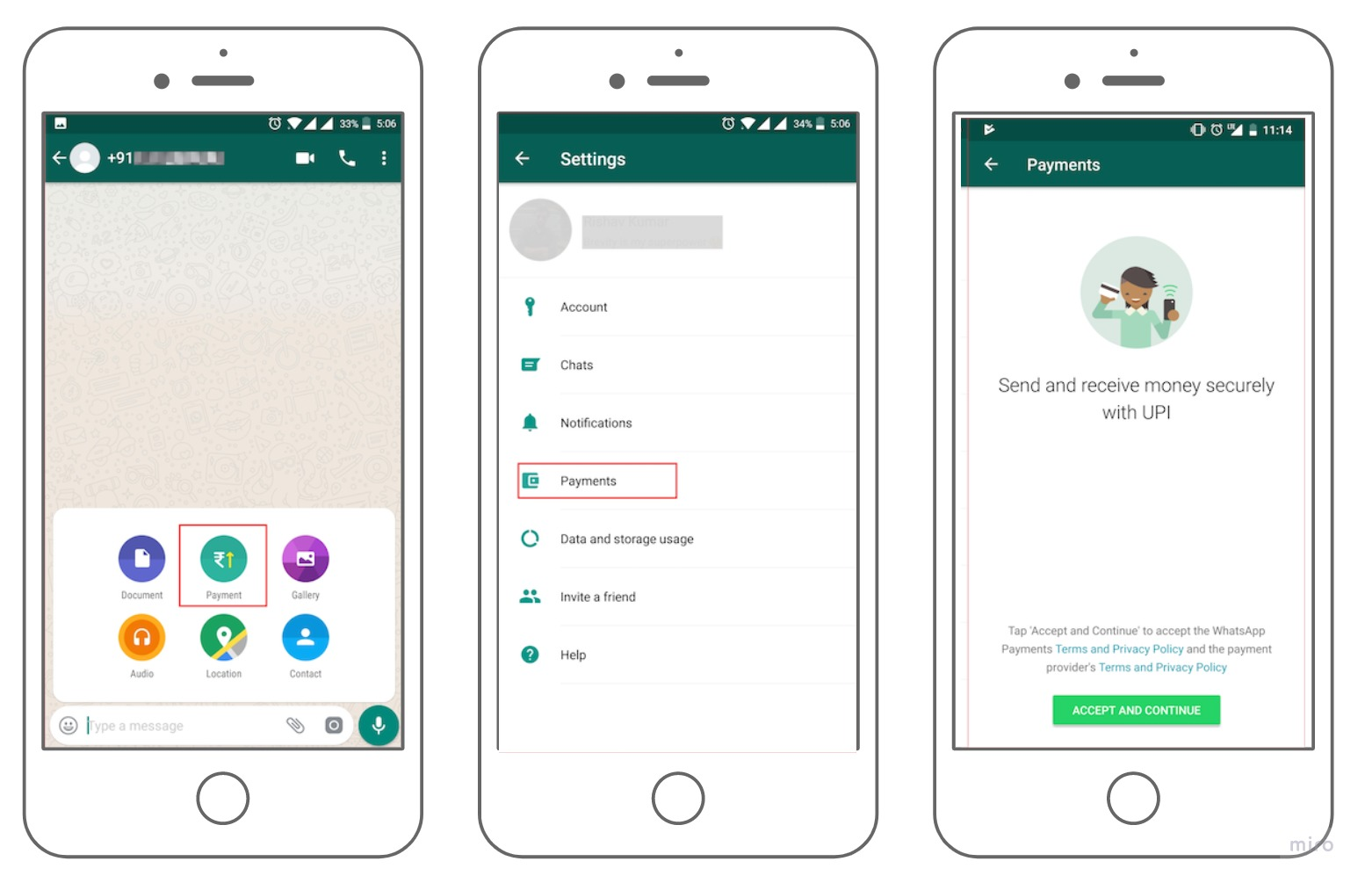

**Figure 9: WhatsApp Pay through Contact Chat**

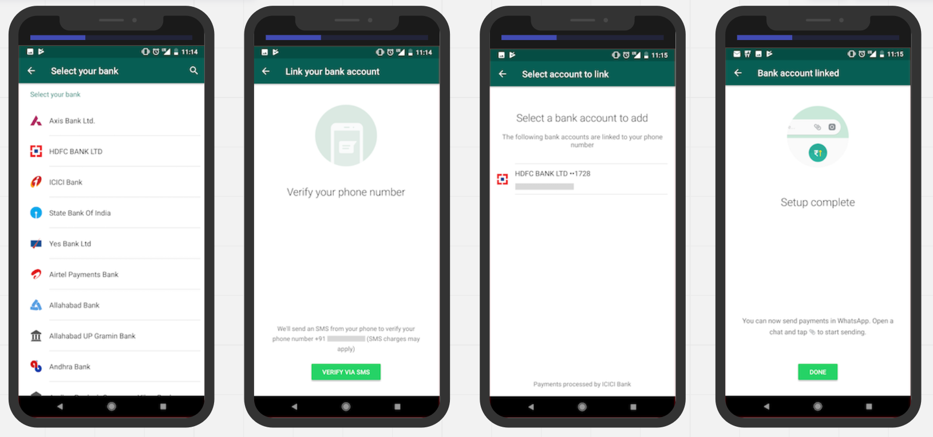

**Figure 10: WhatsApp Pay Bank Account Linking**